**Changes to Monitoring + Pledging + Approval Treatment**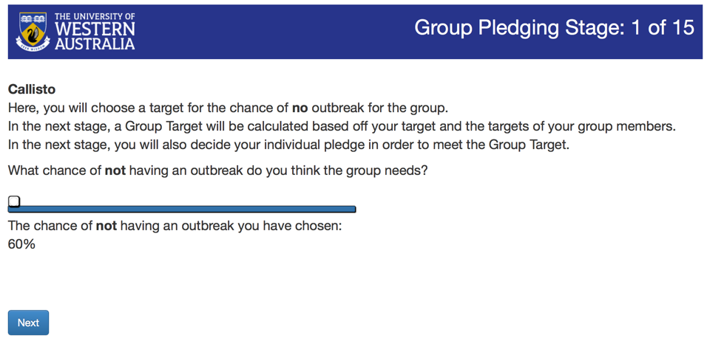

**Suggested modified text:**

Please propose a target level of protection that the group should aim for over the next three rounds. The group target is a value between13% and 100% and represents the chance that an outbreak will **not** occur.

What chance of an outbreak **not** occurring do you think the group should aim for?

“Slider”

The chance of an outbreak **not** occurring that you have chosen is:

**Suggested modified text:**

Based on the proposal of each player, the target for the group over the next three rounds is:

87.0% 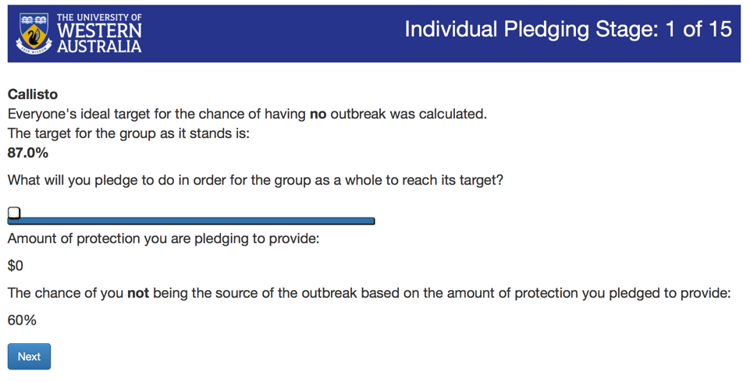

How much effort do you pledge to invest in protecting your crops in order for the group as a whole to reach this target?

“Slider”

The chance of you not being the source of an outbreak based on the amount of protection you pledged to provide is:

**Suggested modified text:**

Please change “you’re” to “you are” beneath the effort slider.

Please change “till” to “until” above the pledge summary table.

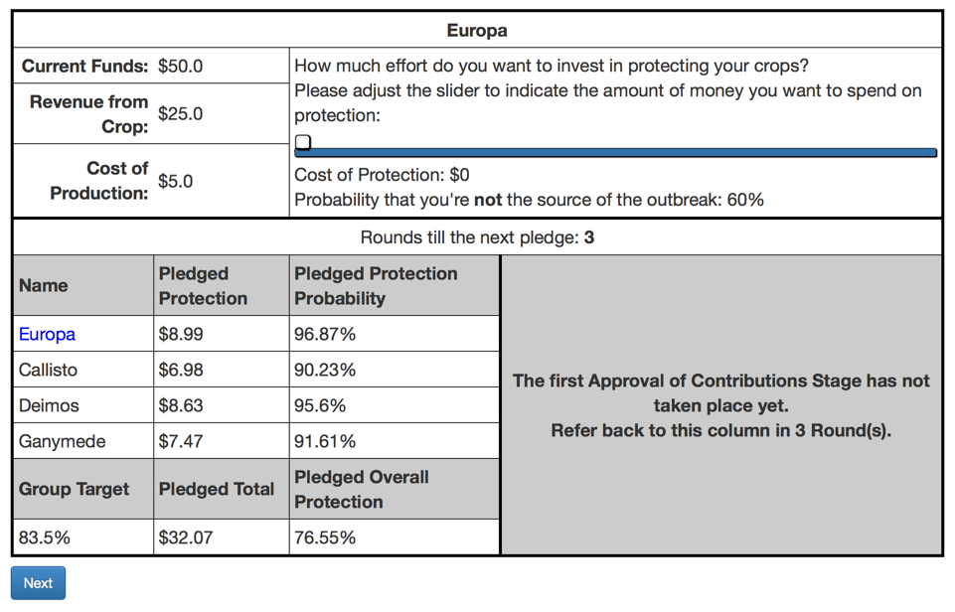

**Suggested modified text:**

Please change “Results of Round 1” to “Round 1 Pledges and Contributions”.

Please change “Cost of Protection” in column 4 to “Actual Protection”.

Please change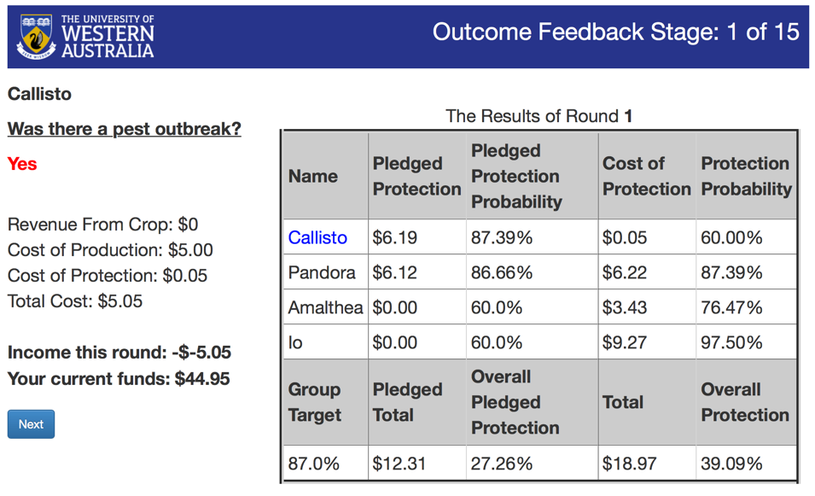 “Protection Probability” in the final column to “Actual Protection Probability”.

As in other versions of the program, “Income this round” includes a double negative.

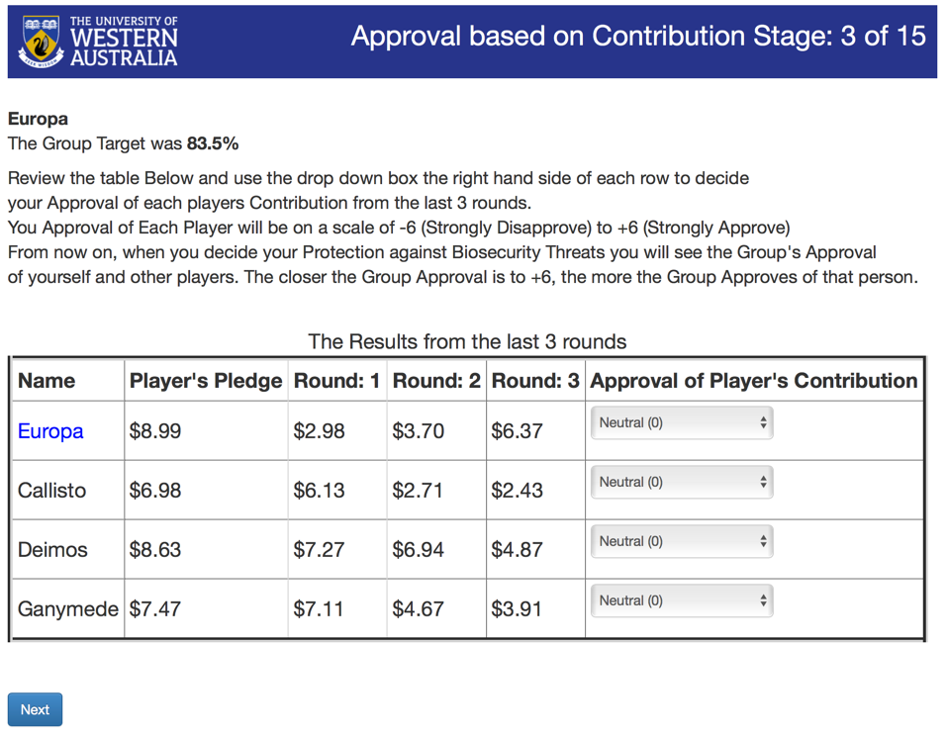

**Suggested modified text:**

Please review your and your co-players contributions over the last three rounds shown in the table below, and assign to each an approval rating using the drop down menu in the final column. Your approval rating can take on any value between -6 (*Strongly Disapprove*) and +6 (*Strongly Approve*). The ratings provided by everyone will be combined to provide an overall approval rating for each individual player. These approval ratings will be communicated to everyone after this stage and again when each player makes their biosecurity protection decision over the next three rounds.

**Comment**

At present, once this stage has exited the next round commences and players submit their next proposal for the group target and individual pledge before they have received any feedback about the approval ratings. I think that the players should get immediate feedback about the approval ratings as well as feedback when they make their contributions. Although the approval is on the contributions, we would still like to see an effect on the pledges as well.

**Comment**

Round the approval scores to whole numbers. Thus, Europa should be -1 and Callisto should be 2. 